A "4:20" Primer

QUESTION ONE- What is "4:20?" (always pronounced four-twenty)

ANSWER- (taken from High Times Magazine) "April 20 at 4:20 PM is the “pot-smokers’ holiday,” also variously described as the “hippie New Year,” “national smoke time,” “national pot-smoking day,” “the holiday,” “pot appreciation day,” “the ultimate session,” or “a day of tribute to the scene.” One enthusiastic smoker reported: “Every group has its holidays, and pot-smokers are no exception. April 20th is the day of worship observed by smokers around the world,” Another said: “It’s comforting to know that hundreds of thousands of other people are lighting up with me on 4/20. It’s about the community identity of marijuana-smokers.”

QUESTION TWO- What is 4:20's origin?

ANSWER- Many theories exist:

- A group of students from San Rafael, California started using the term in the 1970's.

- It is LA police code for marijuana-smoking in progress (the code is actually 11350).

- It is the number of chemicals in the marijuana plant (there are 315, including THC- the active ingredient).

- It is Hitler's birthday and the anniversary of Columbine.

There are others, but no strong evidence to prove they are fact.

QUESTION THREE- What does it mean to us?

ANSWER- Be aware that kids are going to be talking about it. Don't be afraid to talk to the kids about consequences of doing drugs: physical, mental and legal (see talking points below). If it is serious enough contact one of your guidance counselors, SAP personnel, an administrator or PSLO.

When you see the symbol 4:20, 420, or 4/20 be aware of what it represents.
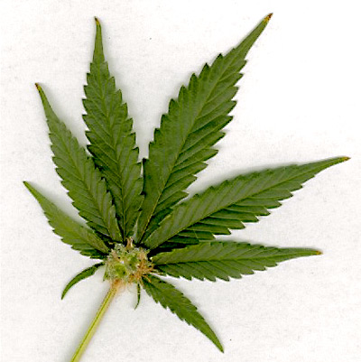

TALKING POINTS:

1) Physical and mental consequences

- To learn how marijuana effects the brain go to this site and take the virtual tour: http://www.theantidrug.com/drug_info/mjmh_virtual_tour.asp

- Weekly marijuana use can increase the risk for mental health problems such as depression, suicidal thoughts, and schizophrenia.

- THC changes the way in which sensory information gets into and is acted on by the hippocampus (effecting learning, memory, and the integration of sensory experiences with emotions and motivations).

- Regular marijuana smokers may have many of the same respiratory problems that tobacco smokers have. The amount of tar and the level of carbon monoxide absorbed are 3-5 times greater than tobacco smokers.

2) Legal consequences

- Criminal charges for drugs/paraphernalia: supervision, jail time (age-dependent) and fines.

- Suspension from school and possible expulsion.

- Co-curricular code consequences.

- Denial of financial aid for college students.

1. El Sohly, M.A. University of Mississippi Potency Monitoring Project, 2004
2. Marijuana: Facts Parents Need to Know, Revised, NIDA, November 1998
3. Bovasso, G.B. (2001), Cannabis abuse as a risk factor for depressive symptoms. Am J Psychiatry 158, 2033-2037
4. Patton, G.C., Coffey C, Carlin J.B., Degenhardt L., Lynskey M., Hall W. (2002) Cannabis use and mental health in young people: cohort study. BMJ 325, 1195-1198
5. Greenblatt, J. (1998), Adolescent self-reported behaviors and their association with marijuana use. National Household Survey on Drug Abuse, 1994-1996 SAMHSA
6. Ibid.
7. Andreasson, S. et al. Cannabis and schizophrenia: A longitudinal study of Swedish conscripts. Lancet, 26: 1483-1486, 1987
8. Arseneault L., et al. Causal association between cannabis and psychosis: examination of the evidence. British Journal of Psychiatry, 184: 110-117, 2004
9. van Os et al. (Dec. 2004) Prospective cohort study of cannabis use, predisposition for psychosis, and psychotic symptoms in young people, British Medical Journal, 330

